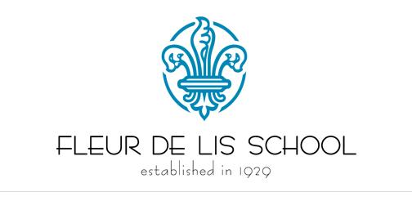

MENU

December 26-30, 2016

 | AM SNACK | LUNCH | PM SNACK
Monday |  | SCHOOL CLOSED  Christmas Holiday
Tuesday | Graham Crackers & Fresh Fruit | Spaghetti, Bread W/Spread, Green Beans, Oranges, Pear & 1% Milk | String Cheese & Wheat Crackers
Wednesday | Cereal & 1% Milk | Soy Nut Butter & Jelly Sandwich, Pretzels, Greek Yogurt, Carrot Sticks, Raisins, Applesauce & 1% Milk | Snack Mix & Fresh Fruit
Thursday | Rice Cakes & Fresh Fruit | Turkey Corn Dogs, Mashed Potatoes, Cooked Peas, Cucumber Slice, Pudding & 1% Milk | Soy Nut Butter on Crackers W/100% Apple Juice
Friday |  | SCHOOL CLOSED  NEW YEARS HOLIDAY

